1. **Install Export to Azure Data Lake add-in**

**(Source:** [**Doc**](https://docs.microsoft.com/en-us/dynamics365/fin-ops-core/dev-itpro/data-entities/configure-export-data-lake)**)**

**&**

1. **Export to Data Lake in Finance & Operations apps**

**(Source:** [**Doc**](https://docs.microsoft.com/en-us/dynamics365/fin-ops-core/dev-itpro/data-entities/finance-data-azure-data-lake)**)**



**1)Install Export to Azure Data Lake add-in**

* **Export to Data Lake Feature:**

This feature lets you copy data from your Finance and Operations apps into your own data lake.

In this you select the data that you want, the system makes an initial copy & makes it available in your data lake. The system then keeps the selected data up to date.

* **Enable the Export to Data Lake feature**

The Export to Data Lake add-in(feature in Finance and Operations environments) must be installed to connect your environment with a data lake.

* **Install the Export to Data Lake add-in in LCS**

In LCS > Navigate to your Environment page > Select the Environment add-ins tab > Select Install a new add-in, and in the dialog box, select Export to Data lake > Select Install a new add-in, and in the dialog box, select Export to Data lake > Accept Terms & Install.

* **Create Service Principal for Microsoft Dynamics ERP Microservices:**

The Export feature is built using a microservice that exports Finance & Operations app data to Azure Data Lake. Microservice uses the Azure service principal, Microsoft Dynamics ERP Microservices, to securely connect to your Azure resources.

**Steps:**

* Go to the Azure Active Directory.
* Select **Manage** > **Enterprise Applications**, and search for the following applications.

| **Application** | **App ID** |
| --- | --- |
| Microsoft Dynamics ERP Microservices | 0cdb527f-a8d1-4bf8-9436-b352c68682b2 |

(Figure1&2 : Securing Service Principle via Key Vault )

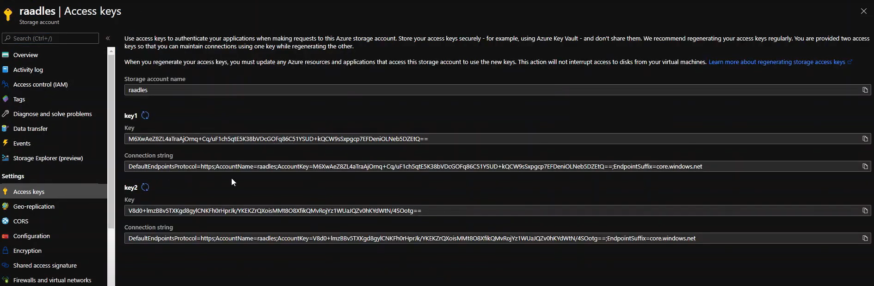

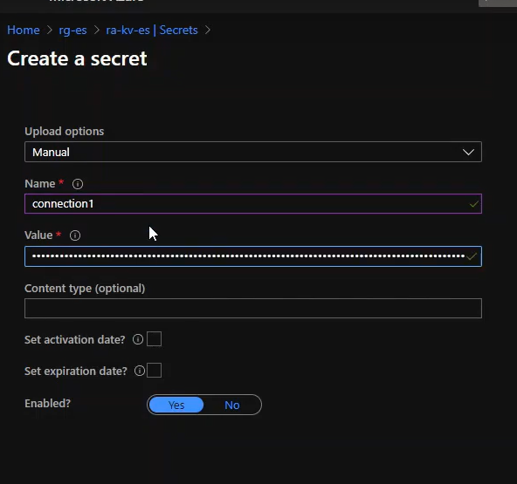

* **Configure Azure Resources:**

The steps, which take place in the Azure portal, are as follows:

1. **Create an application in Azure Active Directory:**

App registration & give API permissions in AAD

**Steps:**

* In Azure portal, select Azure Active Directory, and then select App registrations.
* Select New registration, and enter the following information:

**Name:** Enter a name for the app. & **Supported Account types:** Choose the appropriate option.

* On the left navigation pane, select **API permissions**, select **Add a permission** & in the **Request API permissions** dialog box, select **Azure Key vault**.
* Select **Delegated permissions**, select **user_impersonation**, and then select **Add permissions**.
* On the left navigation pane, select **Certificates & secrets**, and then select **New client secret**.
* In the **Description** field, enter a name, in the **Expires** field, select an option, and then select **Add**. The system will generate a secret and display it under the grid.
* Copy the secret **Value** to the clipboard. This is the value you will need to provide when you set up the key vault later.

(Figure 3,4&5 : Refister app & Add Api Permissions)

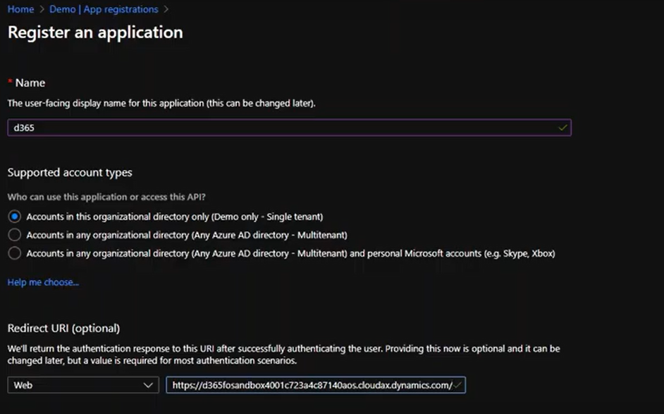

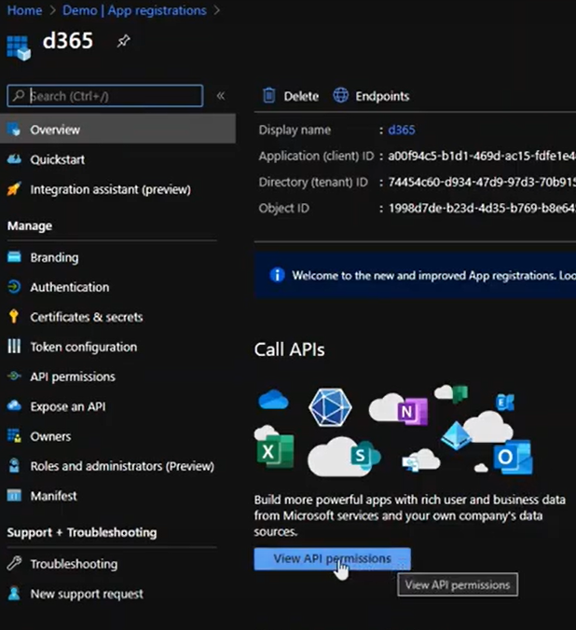

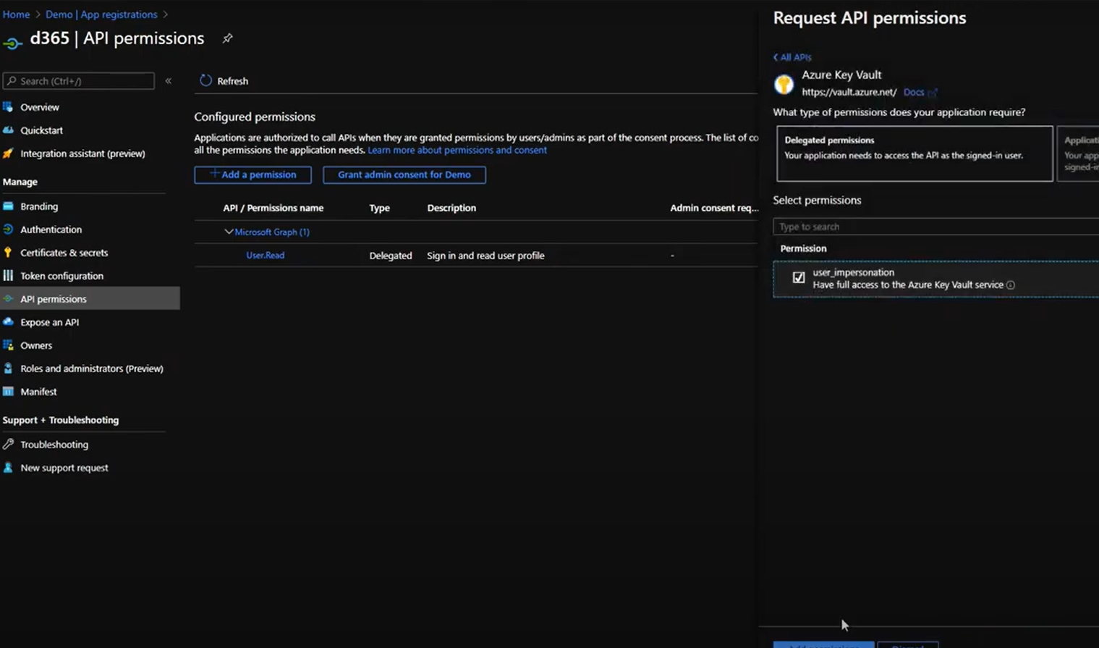

1. **Create a Data Lake Storage (Gen2 account) in your subscription:**

The Data Lake Storage account will be used to store data from your Finance and Operations apps

(Figure 6: Data Lake Storage (Gen2 account) )

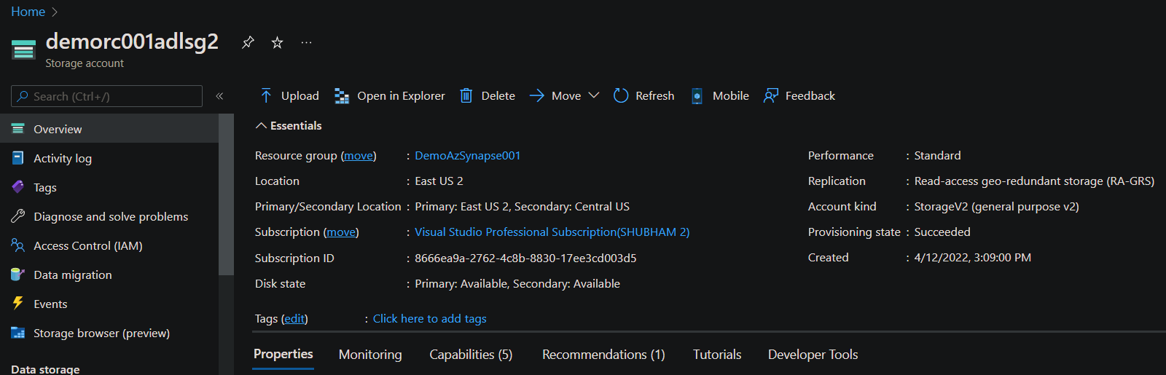

1. **Grant access control roles to applications:**

This step is to grant application permissions to read and write to the storage account. .( in Access Control)

**Steps:**

* In **Azure portal**, open the storage account, select **Access Control (IAM)**, select the **Role assignments** tab, select **Add** at the top of the page.
* Select **Add role assignment** dialog box, select **Role** field, then select **Storage blob data contributor**.
* In the **Select** field, select the application that you registered earlier, select **Save**.
* Repeat steps 2-3 to add the **Storage blob data reader** role.
* Validate the storage account role assignment for the application you created earlier.

(Figure 7,8 & 9: Granting Access of Storage blob)

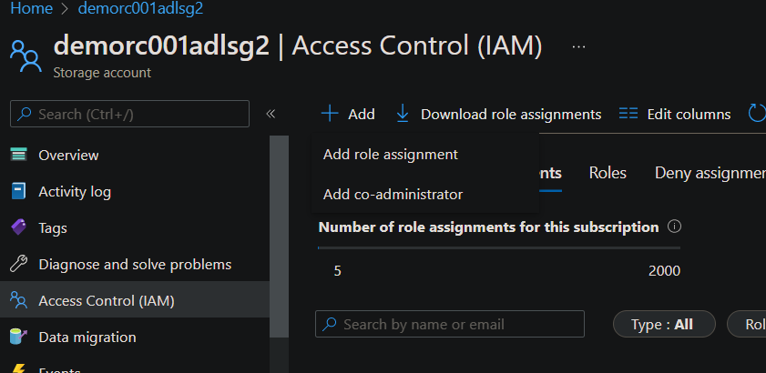

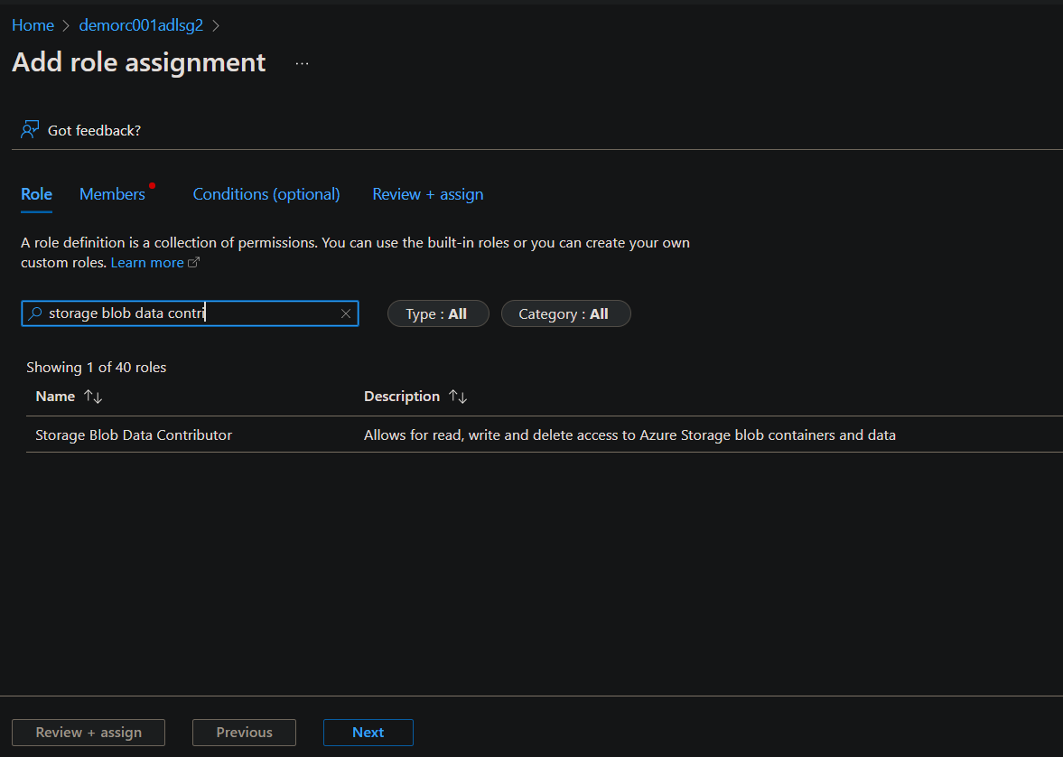

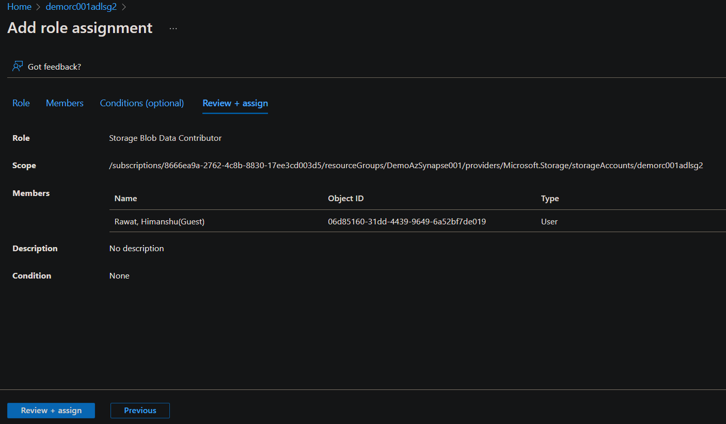

1. **Create a key vault**:

This step will provide a secure way to share details such as storage account name to Finance and Operations apps.

(Figure 10: Created Key Vault)

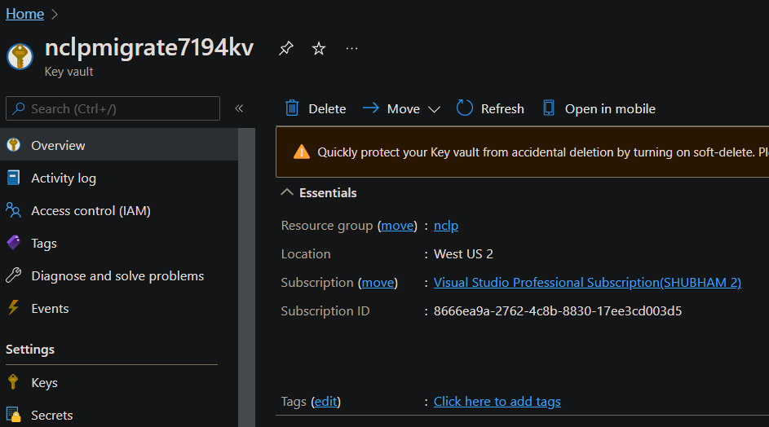

1. **Add secrets to the key vault:**

We will create 4 secrets in the Key vault and then add the values saved from previous steps.

Secrets:

* app-id(The ID of the application created earlier.)
* app-secret(The client secret specified earlier.)
* DNS name
* storage-account-name(The name of the storage account created earlier.)

At end enter these details in F&O.

(Figure 11: Enter Connecting data in F&O)

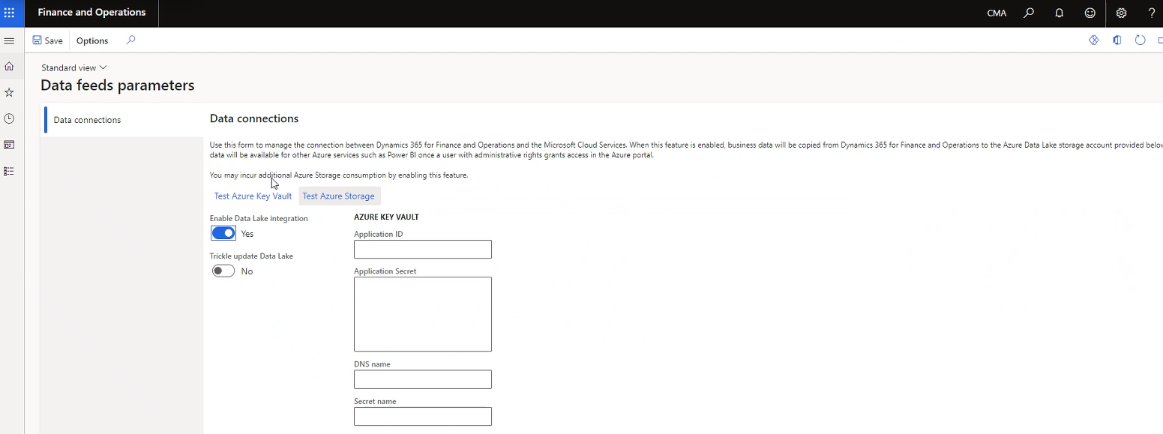

1. **Authorize the application to read secrets in the key vault:**

Add access policy

(Figure 12: Linking d365 with key vault)

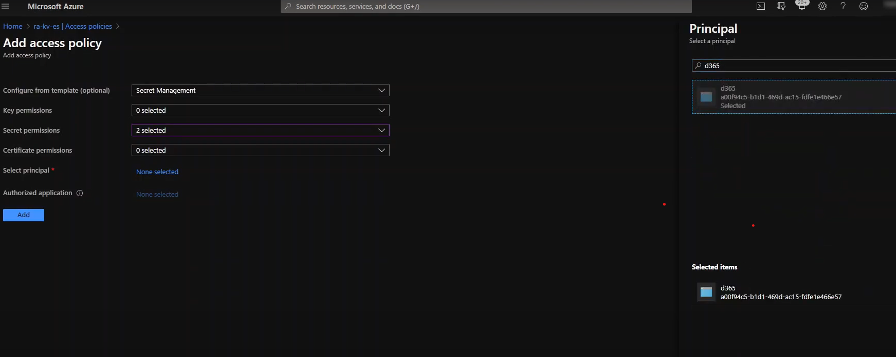

**Note:** By this time Export to Data Lake add-in is installed in F & O apps

Now,

**2)Export to Data Lake in Finance & Operations apps**

**I. Select data:**

We can select the tables and entities that should be staged in Data Lake:

* In your environment, go to **System Administration** > **Setup** > **Export to Data Lake**.
* Click on the **Choose Tables tab**, select the data tables that should be staged in Data Lake.
* Now select **Add Tables** to add the selected tables to Data Lake.
* Select **Activate data feed**, and then select **OK**.

We can select tables by using entities also. Entities are higher-level abstraction of data and might include multiple tables. By selecting entities, you also select the tables that include them.

* On the Choose using **Entities tab**, select the entities, and then select **Add Tables using Entities**.

There can be 3 status shown while transfer process: **Running** , **Initializing**or**Deactivated**.

(Figure 13 & 14: Exporting data via Choose Table & Choose Entities)

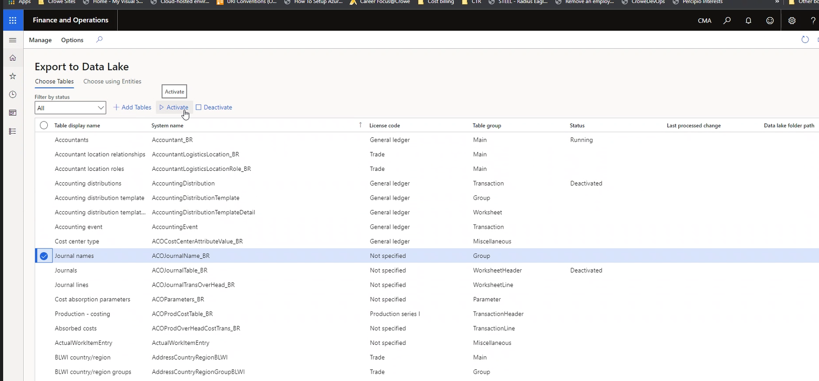

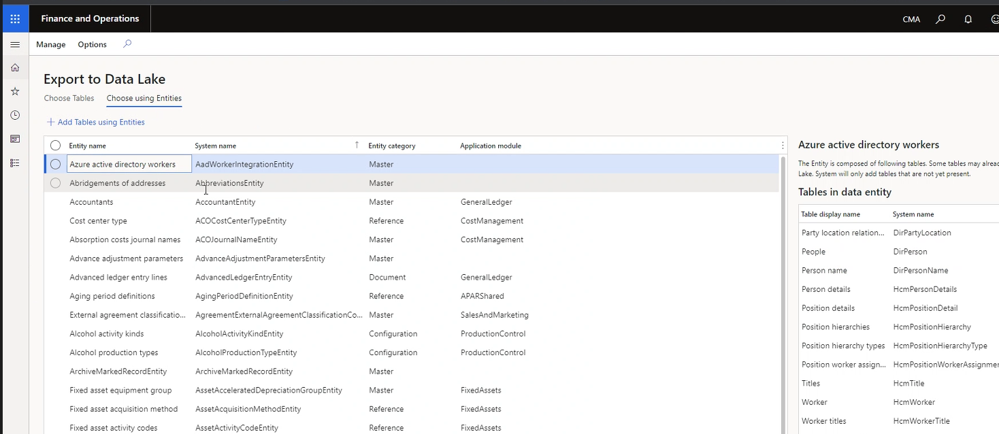

**Note:** By this time data transfer will took place.

Now,

* Check data in Storage Account:

(Figure 16: Data transfer completed and reached in Data Lake)

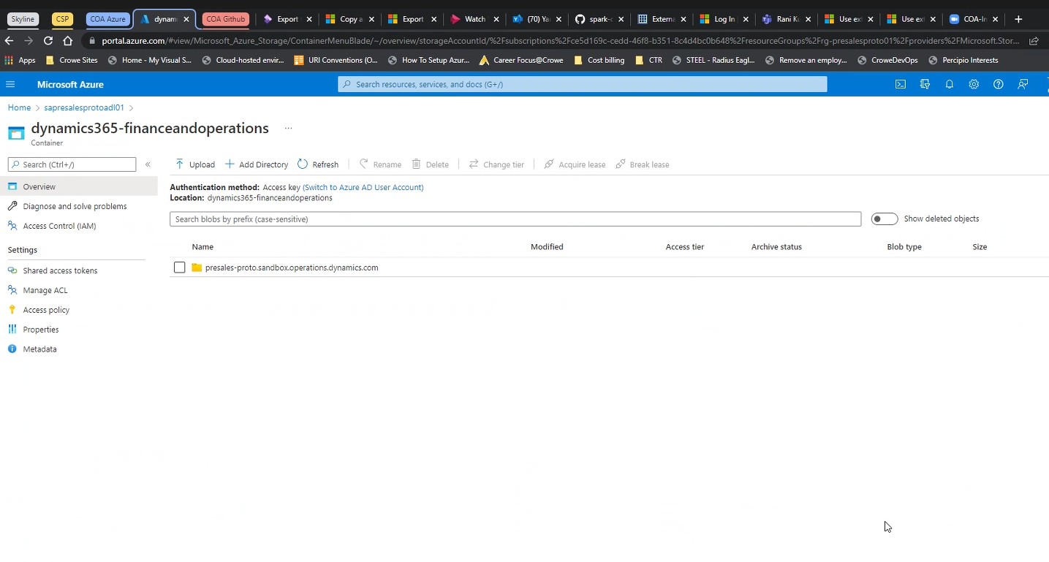

**-Monitor the tables in Data Lake:**

Data will show up in data lake in short span of time. We can view the status of ongoing data exports in the Status column on the Export to Data Lake page.